Global CA
# Source: AI Source: Provided by: [Data Path: Persons Table -> ID Column: 1, Name_En Column: Motasem Essam] -> From: [ChatGPT] on [1/18/2026]
Global or well-known Certificate Authorities (CAs) are trusted organizations recognized worldwide that issue digital certificates for websites, servers, software, and devices. These CAs are automatically trusted by web browsers, operating systems, and apps, which allows secure communication over the internet.
Think of them as official “notaries” for the web”—if they vouch for a website, your browser trusts it.

🔑 Key Features
# Source: AI Source: Provided by: [Data Path: Persons Table -> ID Column: 1, Name_En Column: Motasem Essam] -> From: [ChatGPT] on [1/18/2026]
- Trusted by browsers and OS
  - Browsers like Chrome, Firefox, Safari, and OSes like Windows, macOS include a list of “root CAs”
  - Any certificate signed by a trusted CA is automatically trusted
- Issue certificates globally
  - Domain Validation (DV) → verifies domain ownership
  - Organization Validation (OV) → verifies company identity
  - Extended Validation (EV) → verifies legal entity with stricter checks
- Provide secure services
  - HTTPS certificates for websites
  - Email encryption (S/MIME)
  - Code signing certificates
  - VPN and client authentication

📍 Examples of Global / Well-known Cas
# Source: AI Source: Provided by: [Data Path: Persons Table -> ID Column: 1, Name_En Column: Motasem Essam] -> From: [ChatGPT] on [1/18/2026]
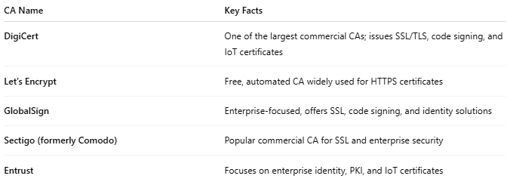
CA Name | Key Facts
DigiCert | One of the largest commercial CAs; issues SSL/TLS, code signing, and IoT certificates
Let’s Encrypt | Free, automated CA widely used for HTTPS certificates
GlobalSign | Enterprise-focused, offers SSL, code signing, and identity solutions
Sectigo (formerly Comodo) | Popular commercial CA for SSL and enterprise security
Entrust | Focuses on enterprise identity, PKI, and IoT certificates

🛠️ Why they matter
# Source: AI Source: Provided by: [Data Path: Persons Table -> ID Column: 1, Name_En Column: Motasem Essam] -> From: [ChatGPT] on [1/18/2026]
- Ensure HTTPS connections are trusted
- Enable secure online banking, e-commerce, and email
- Prevent man-in-the-middle attacks
- Provide auditable trust chains for digital certificates

🔒 Security Note
# Source: AI Source: Provided by: [Data Path: Persons Table -> ID Column: 1, Name_En Column: Motasem Essam] -> From: [ChatGPT] on [1/18/2026]
- The CA’s root certificate is critical.
- If a root CA is compromised → all certificates issued by that CA are untrustworthy.
- Browsers will block websites with certificates from untrusted CAs.

🧠 Authentication Factor
# Source: AI Source: Provided by: [Data Path: Persons Table -> ID Column: 1, Name_En Column: Motasem Essam] -> From: [ChatGPT] on [1/18/2026]
- Something you have → possession of the certificate (private key + certificate) proves identity to a server or service
- Often combined with other factors for multi-factor authentication (MFA):
  - Something you know → PIN or password protecting the private key
  - Something you are → biometric verification in some enterprise systems

Quick analogy
# Source: AI Source: Provided by: [Data Path: Persons Table -> ID Column: 1, Name_En Column: Motasem Essam] -> From: [ChatGPT] on [1/18/2026]
- Well-known CA = Global Notary Office
- Certificate = Notarized document for a website or user
- Browser trust = Acceptance of notarized document

